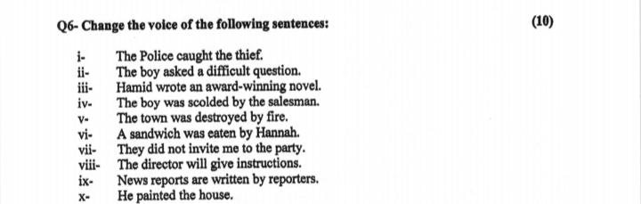Active passive Test.

Q1 The police officer arrested the man.

Q2,The driver was blowing the horn

Q3,The hunter shot the tiger

Q4They will demolish the entire block

Q5 Warned you have been

Q6,He teaches us grammar

Q7 In winter people do not take a bath.

Q8.Sugar is grown in Cuba

Q9,Help me.

Q10,Get out.

Change into Active voice

: You are ordered to get out.

: Let it not be touched.

She was not beaten by me.

This experience will never be forgotten by me.

The girl was teased by the boy.

Was her duty done by her?

The deer was being chased by the tiger

A novel has been written by her.